Azure DevOps

Week -4

Emp Name – Ahmed Taufique

Emp id – 1433732

1. Deploy .net app in azure dev ops from azure demo generator

A.

Step-1 : Create a project named dotnet

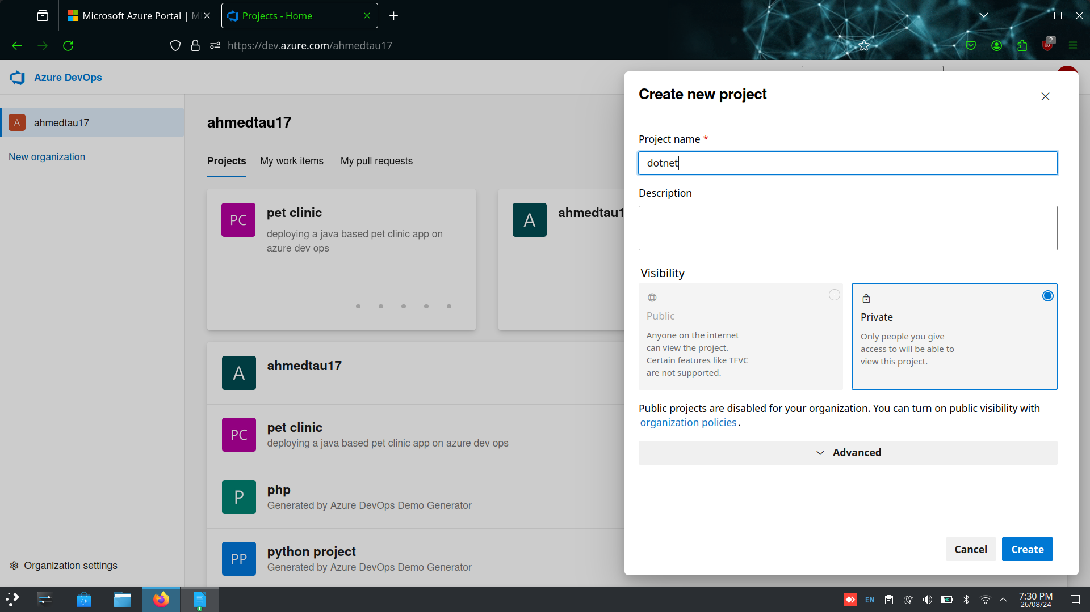

Step-2: Import the following repo from github to azure dev ops

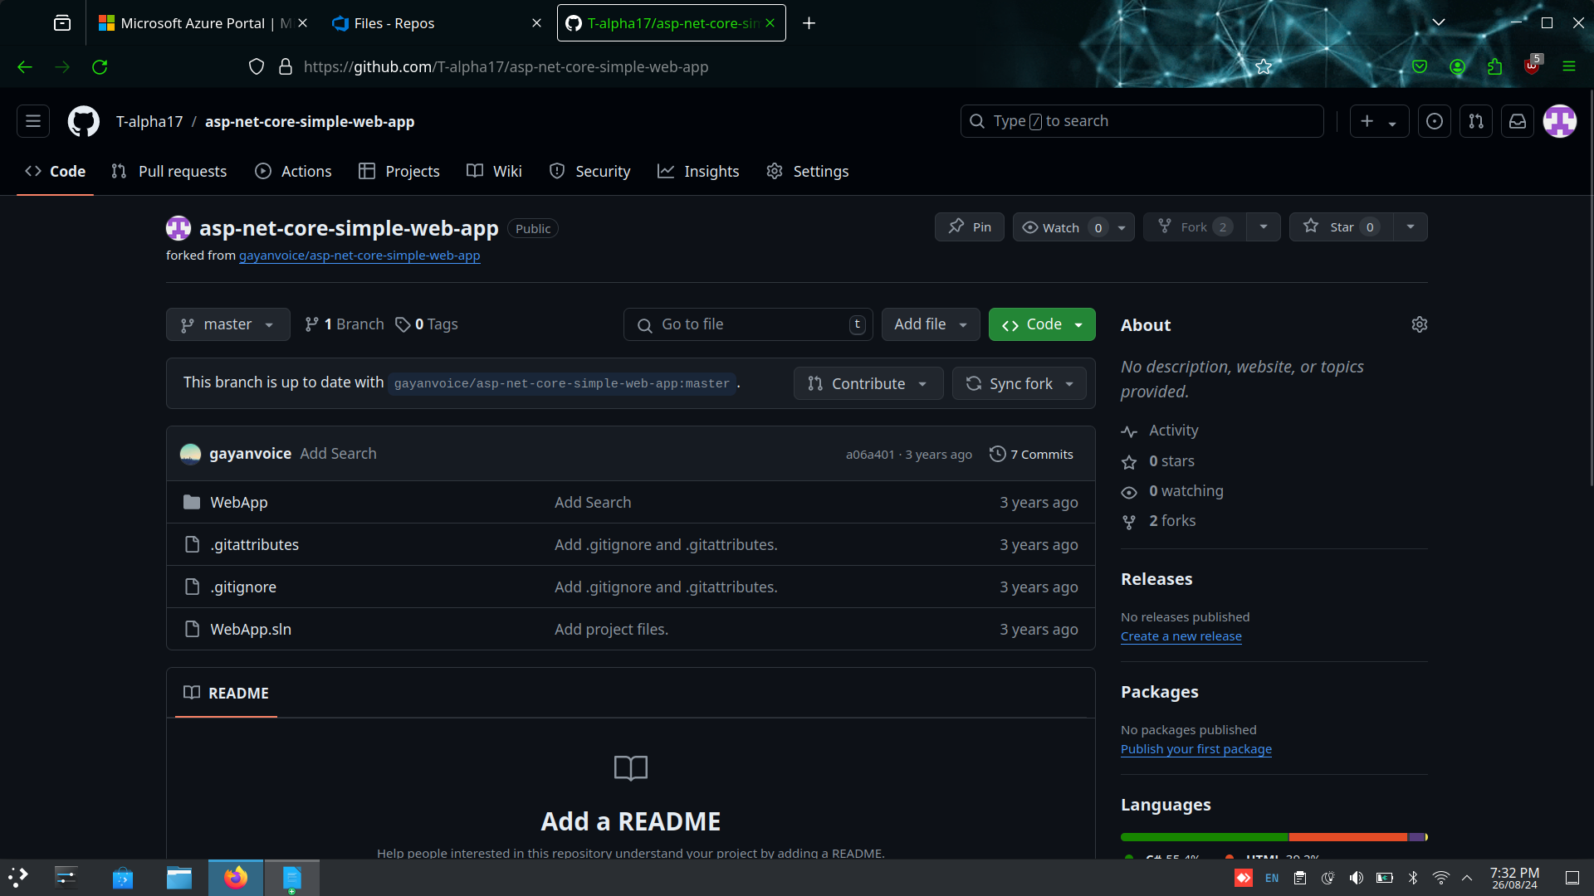

Step-3 : Create a pipeline using azure repo git > dotnet > asp.net template

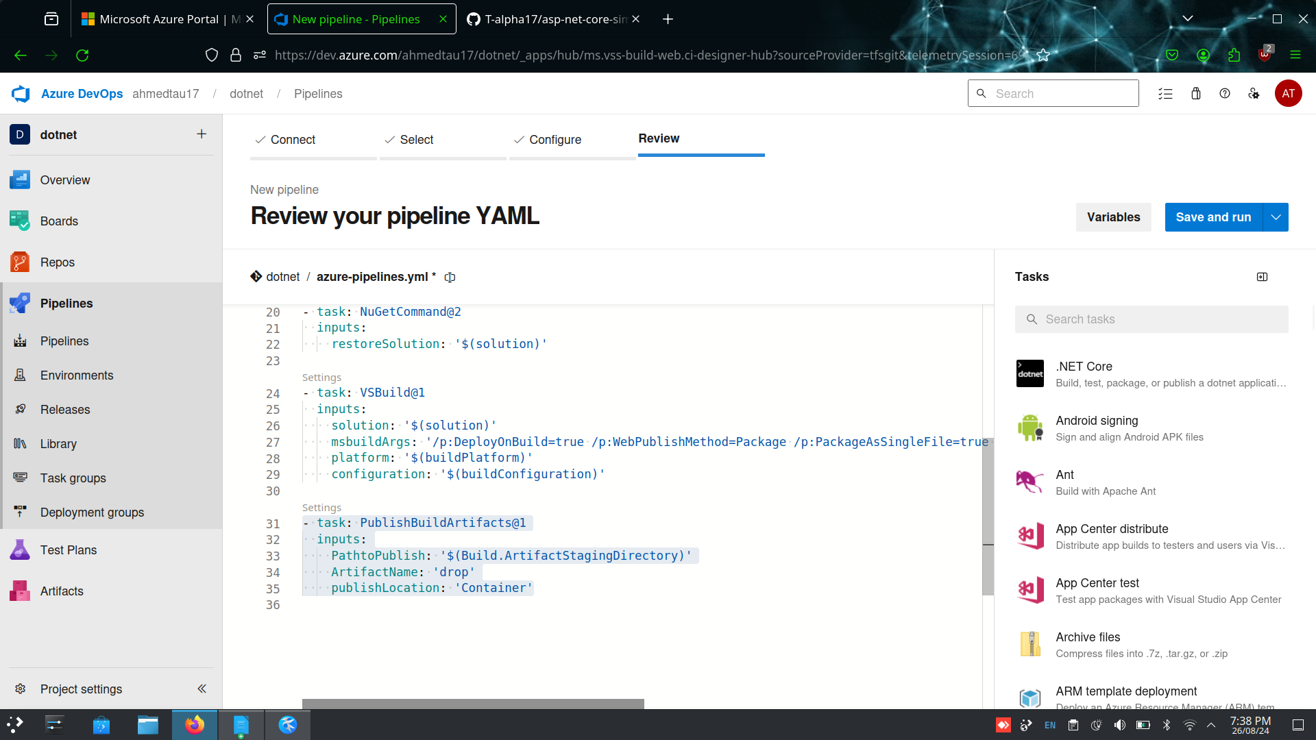

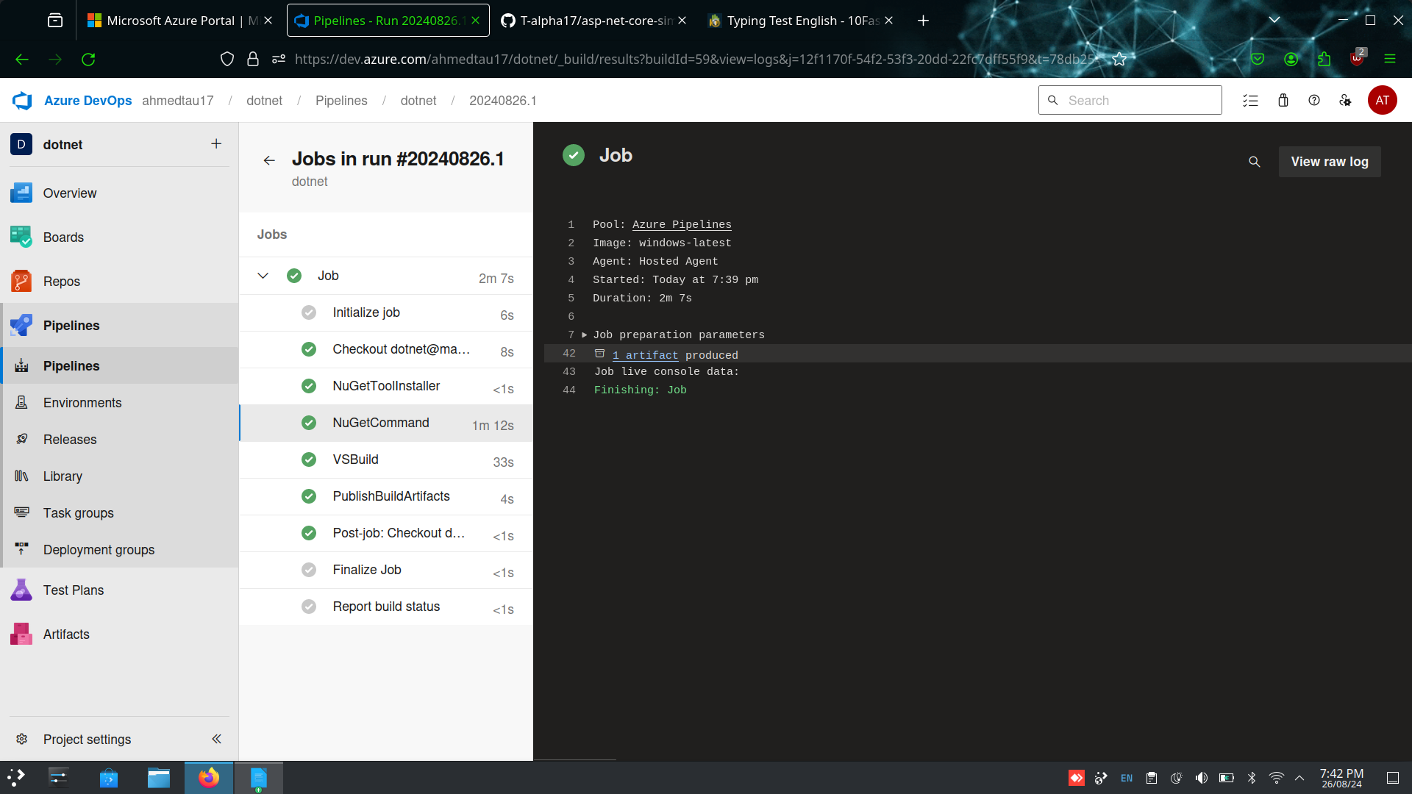

Step-4 : Check for the artifact

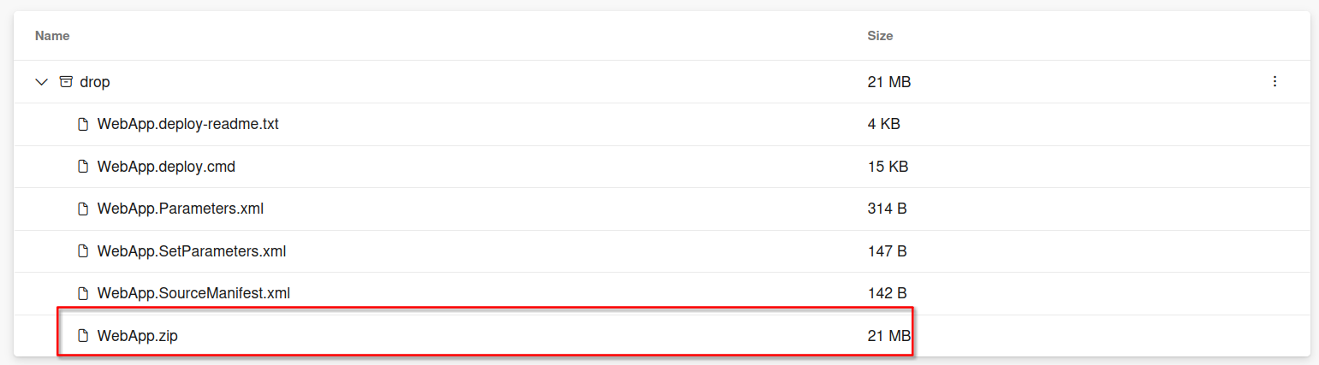

Step-5: Create the release pipeline

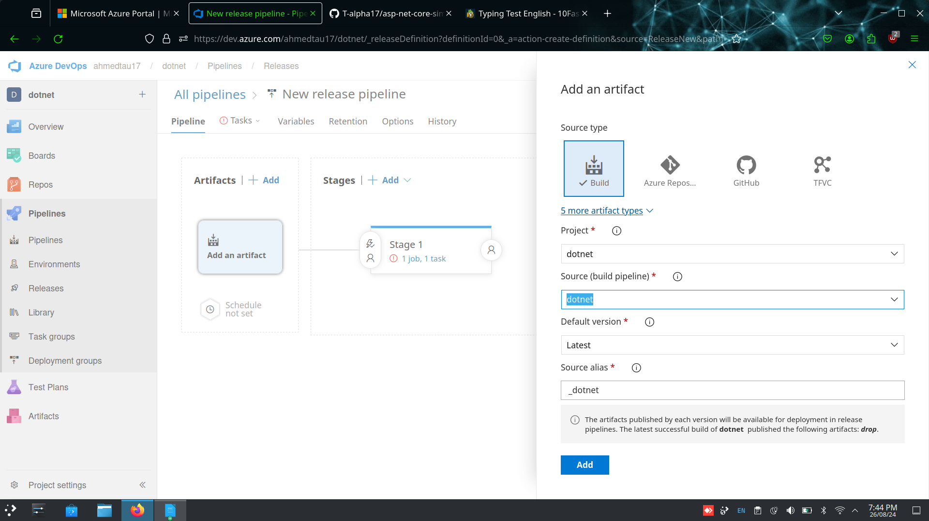

Step-6 : Enable continous deployment trigger

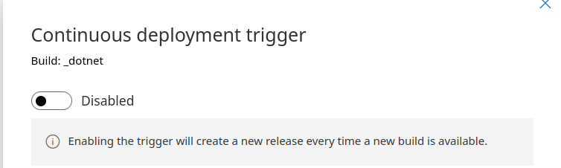

Step-7 : Select the run agent

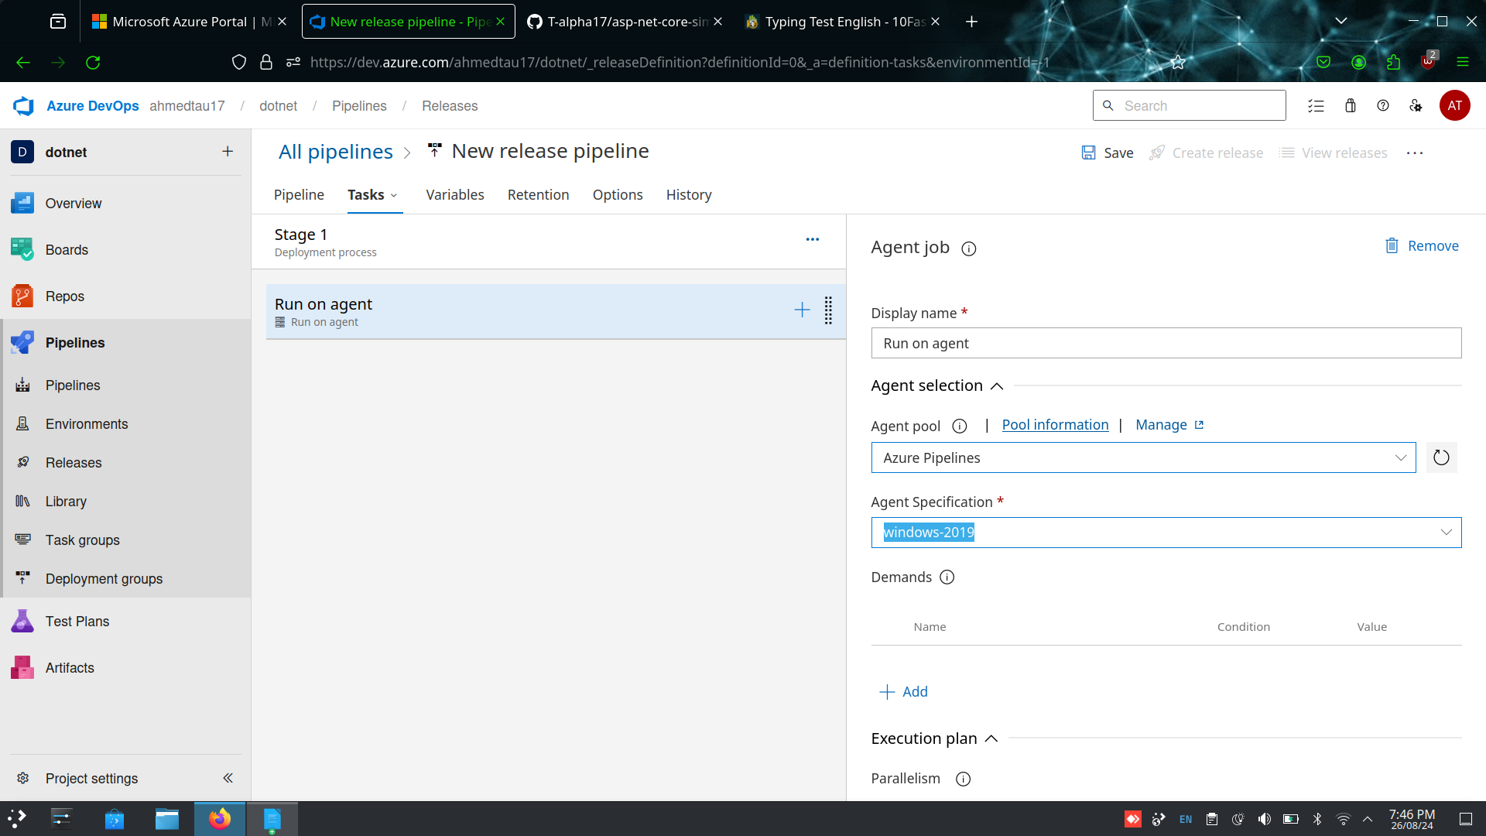

Step-8 : Add the azure cli and select version 1.* and write the inline script

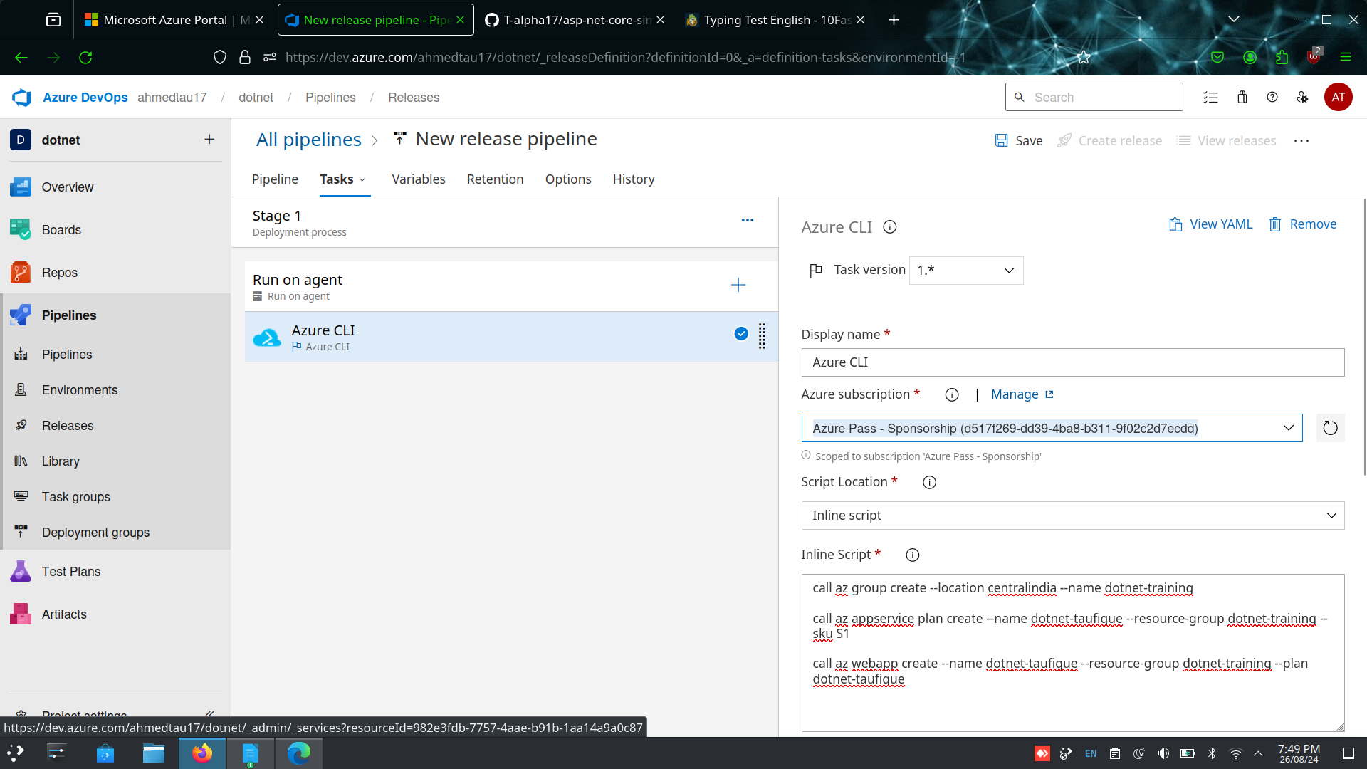

Step-9: Add the app service deploy and give the path of the artifact and then save and create release

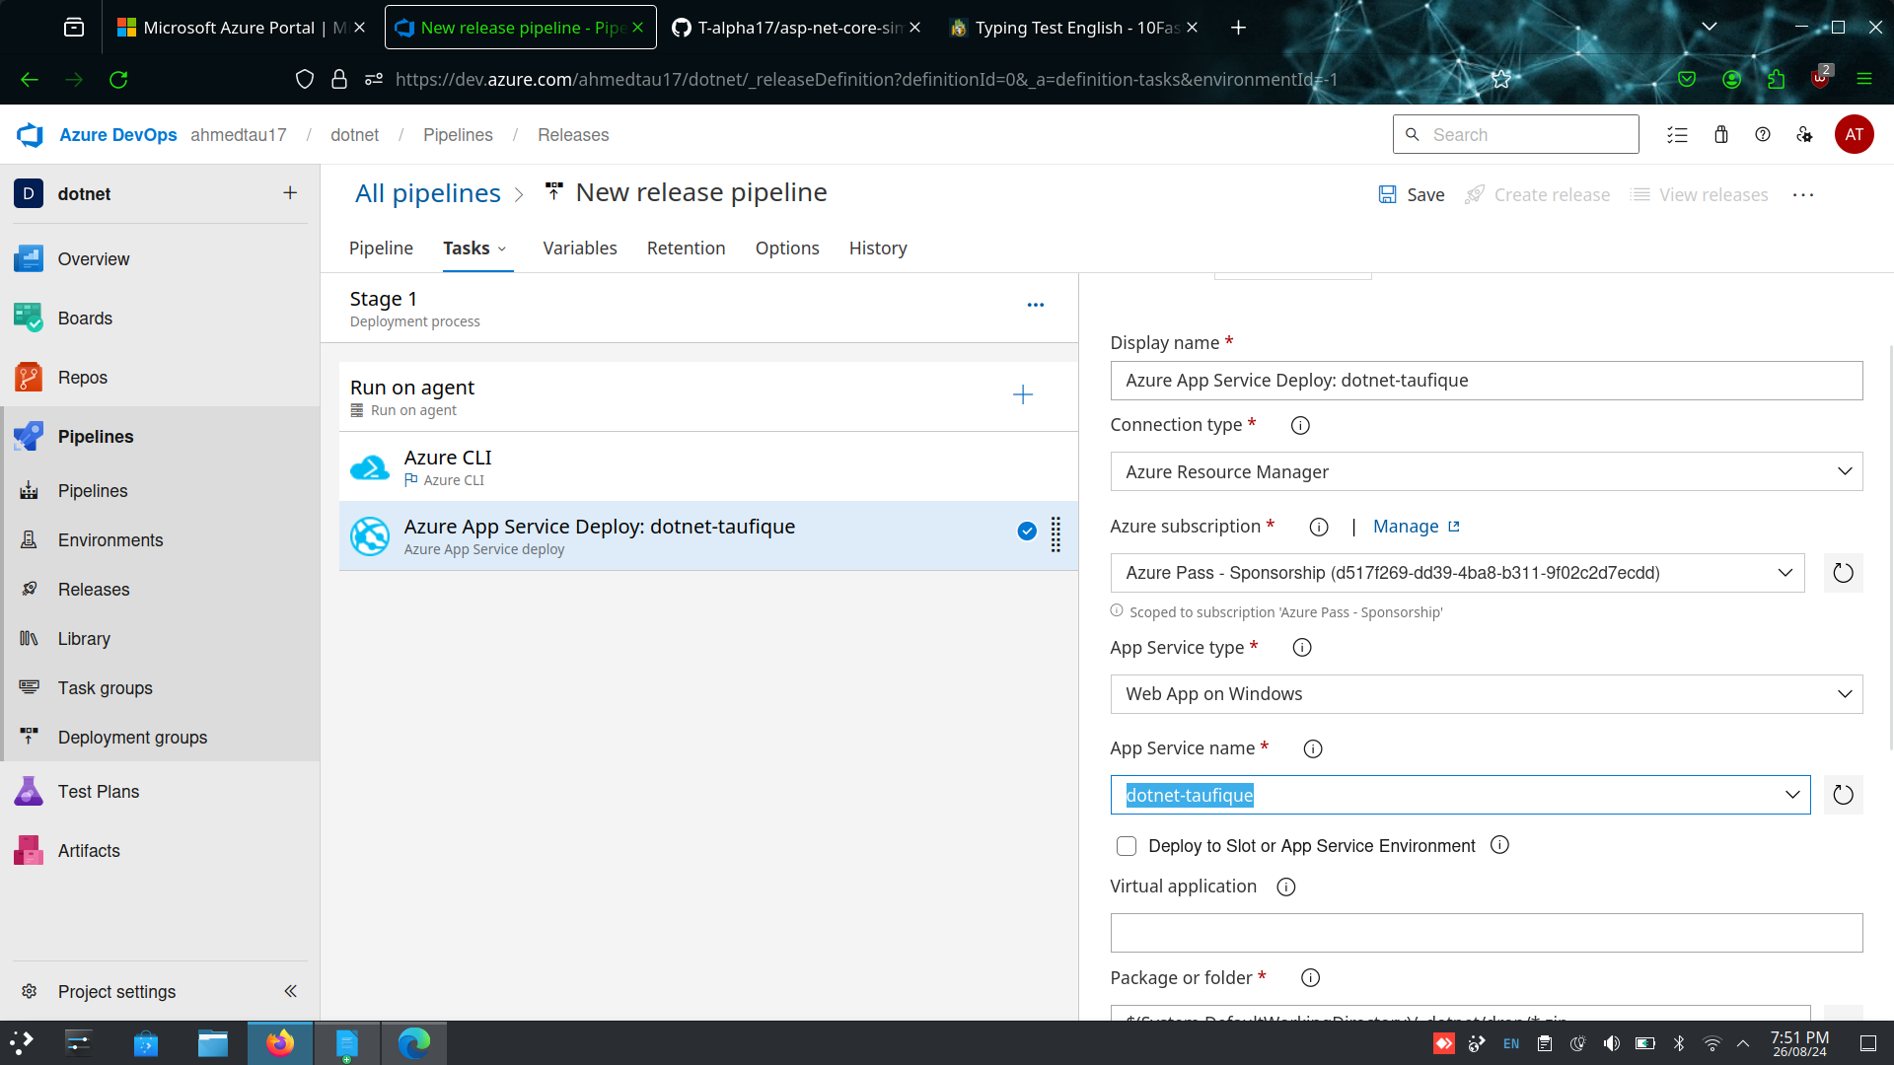

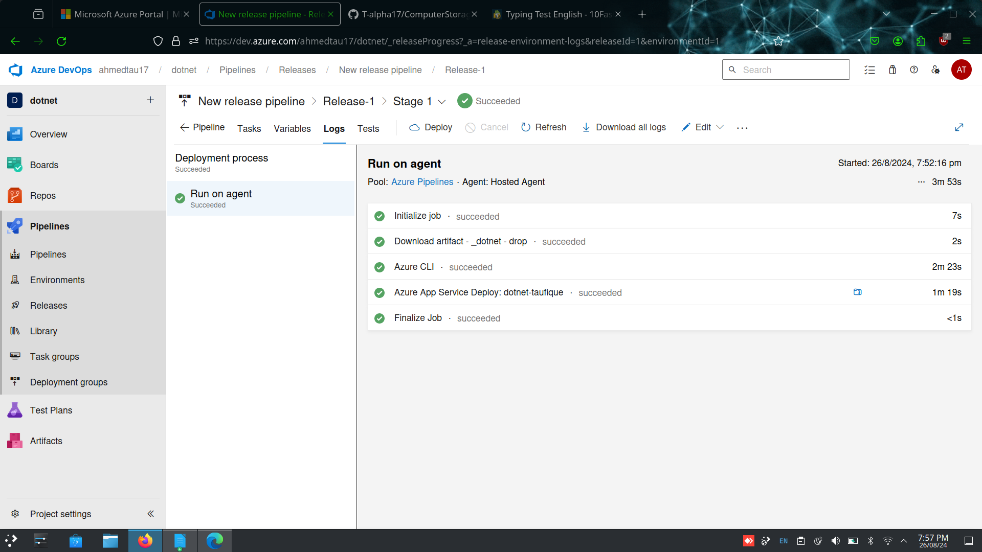

Step-10 : Click on browse to view the landing page of the .net webapp

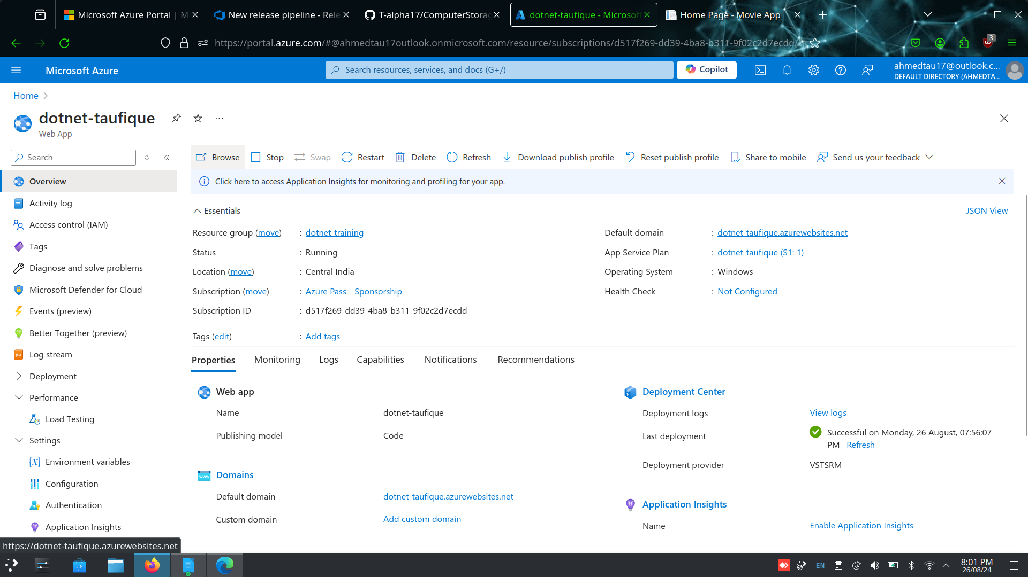

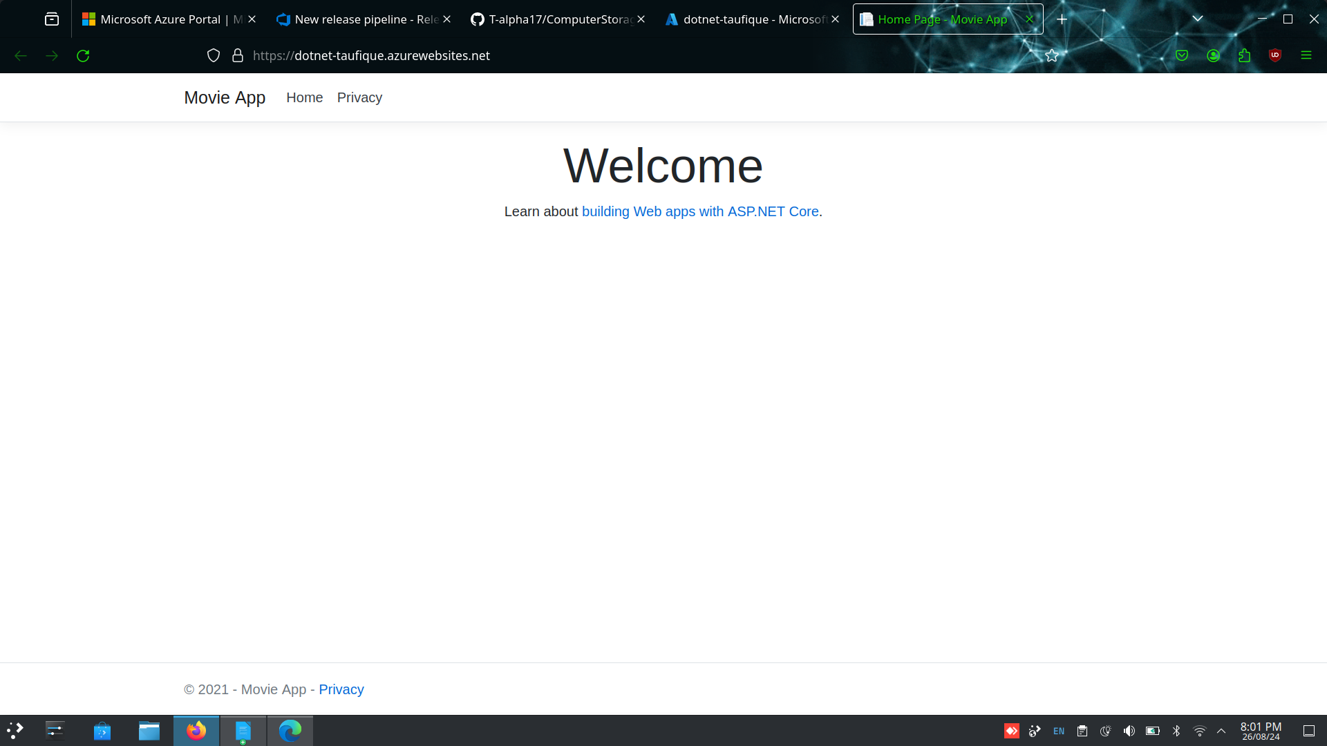

2. Deploy the pet clinic in azure dev ops

A.

Step-1 : Create a project named pet clinic

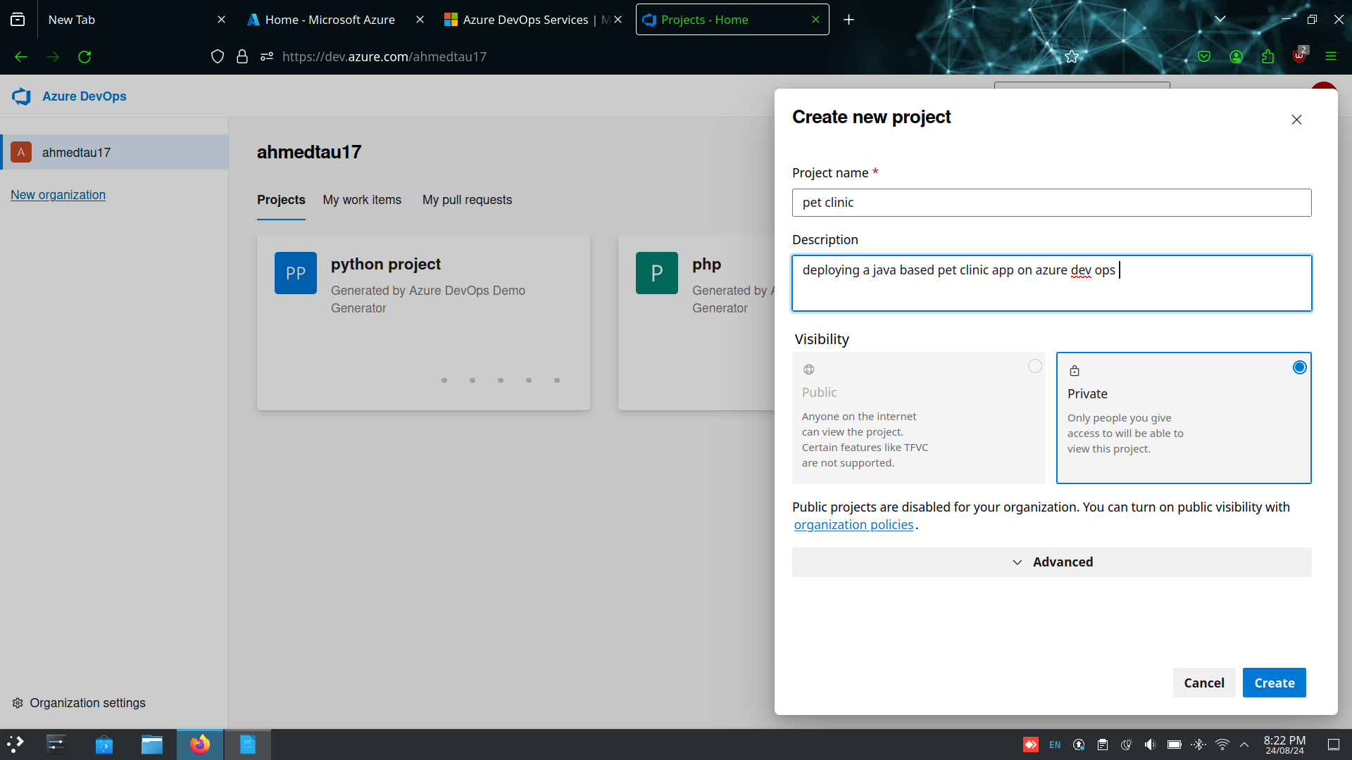

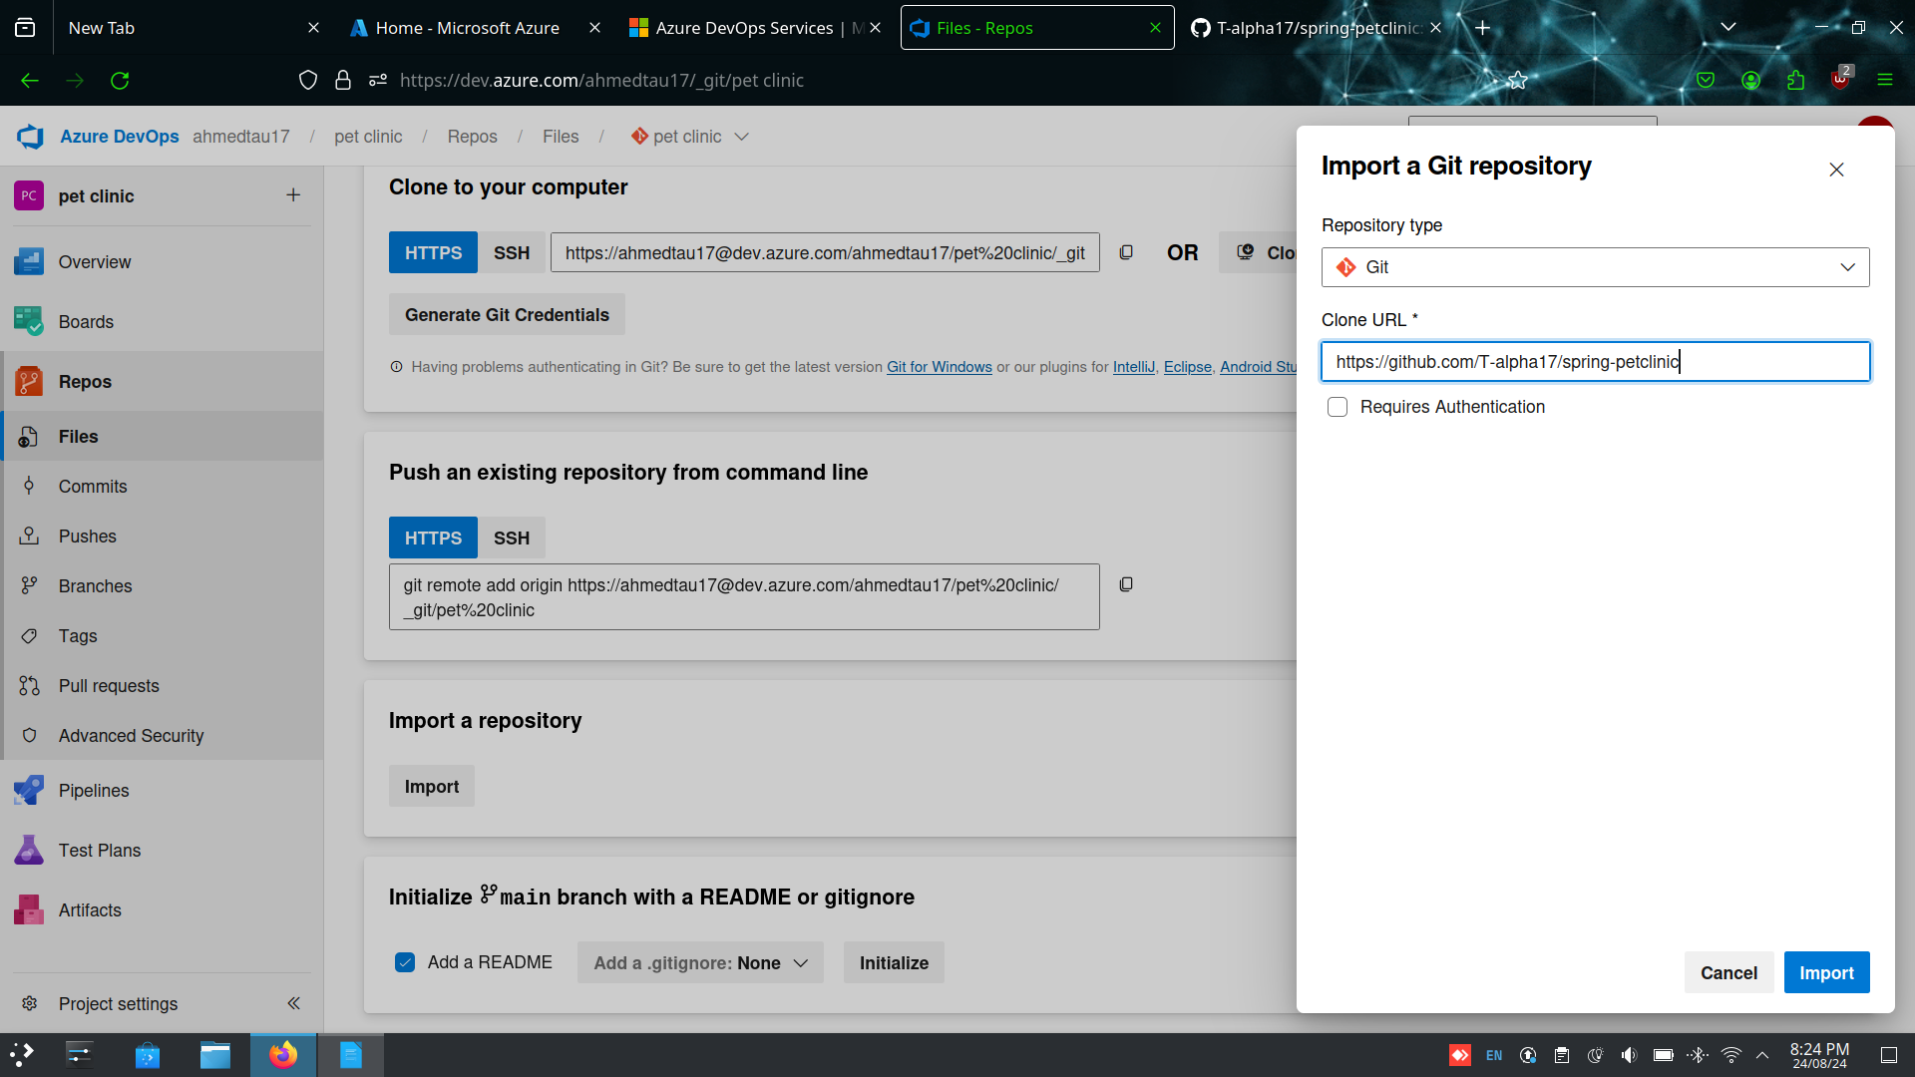Step-2 : Go to repos and import the spring pet-clinic repository from the github

Step-3 : Go to pipelines and create a new pipeline select a new starter pipeline while configuring

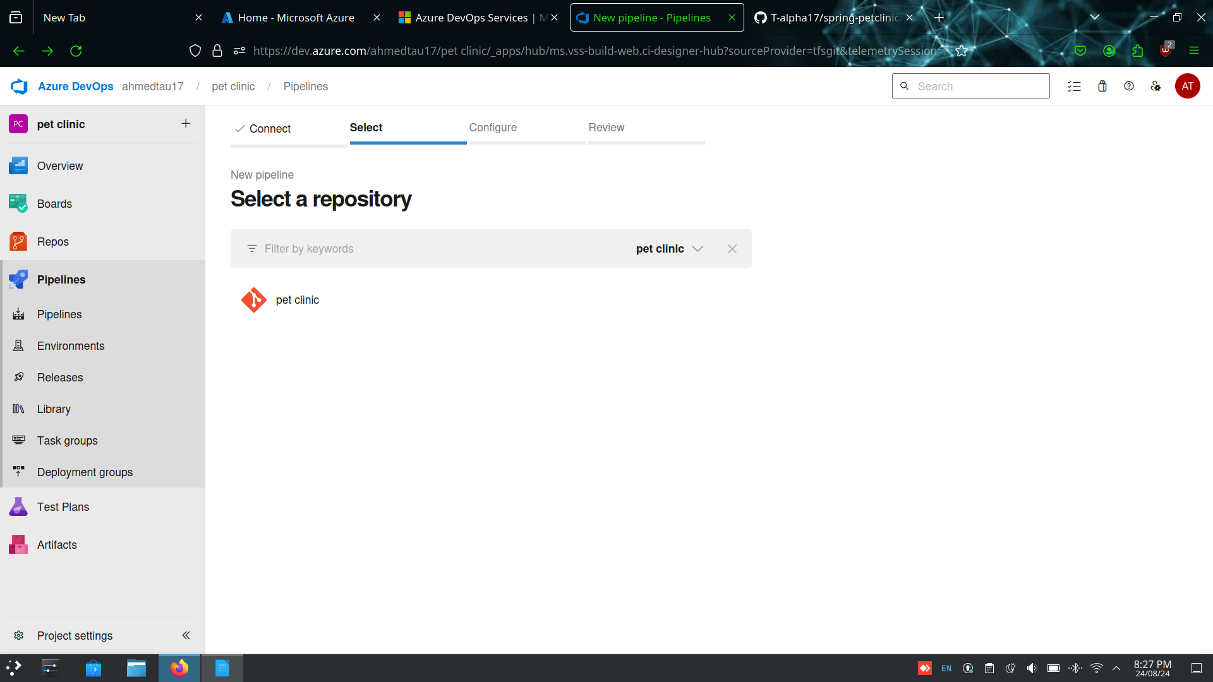

Step-4 : Write the YAML file and validate and save and make sure yo change the jdk version to 17

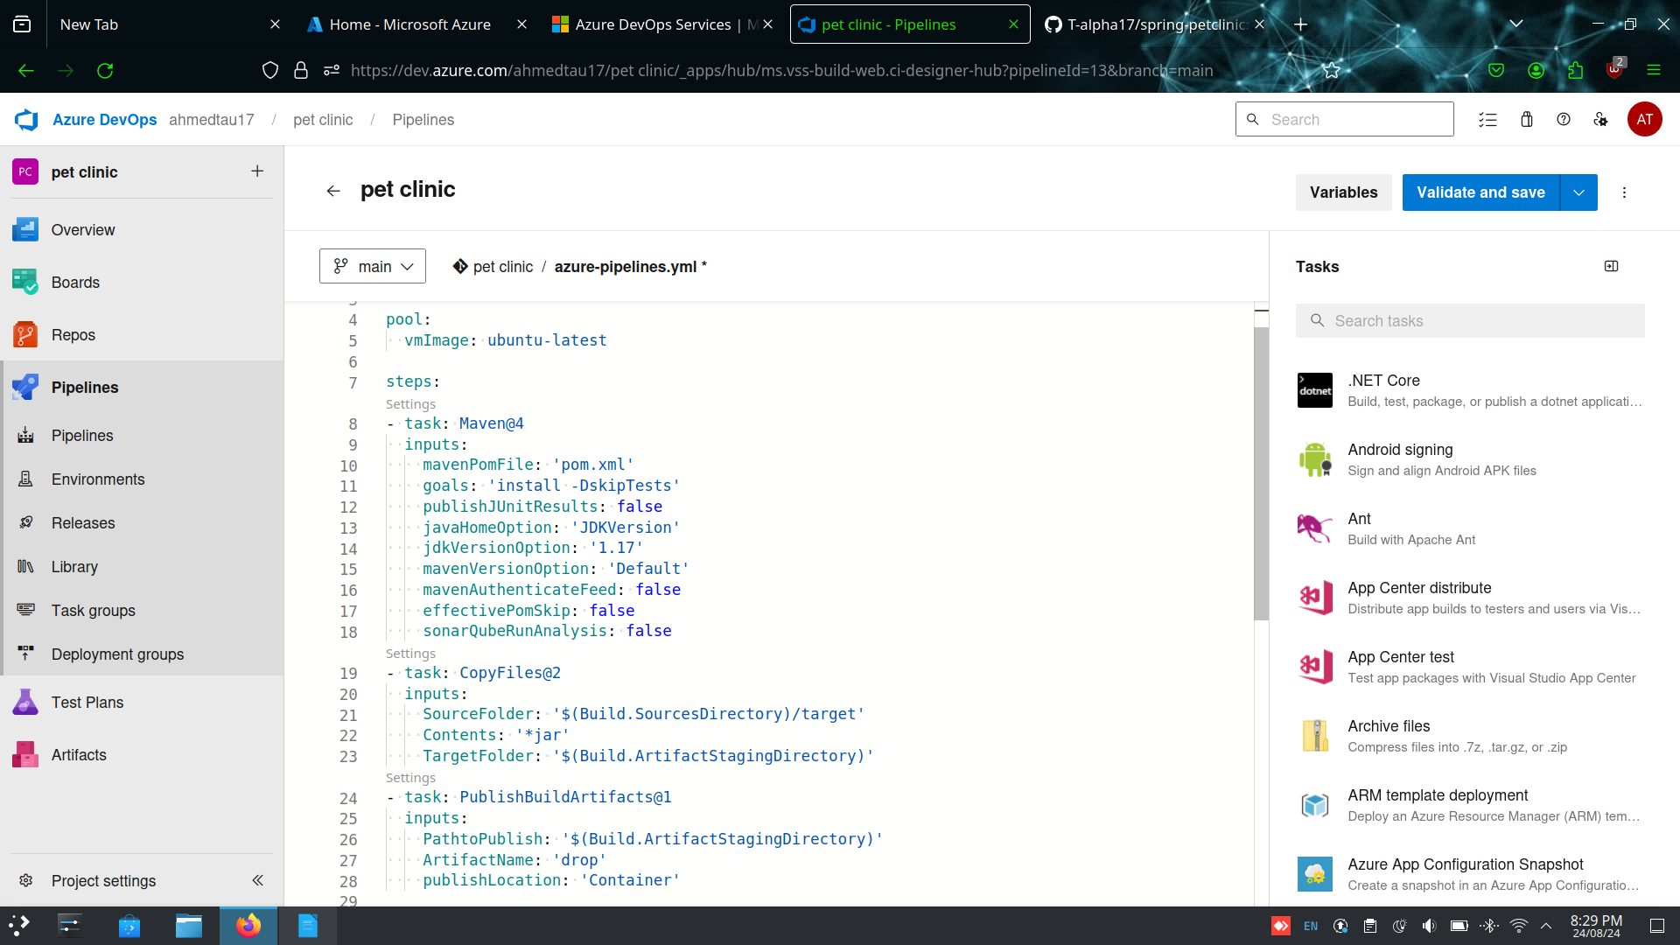

Step-5: Make sure that all jobs run successfully and check if the artifcate is created or not

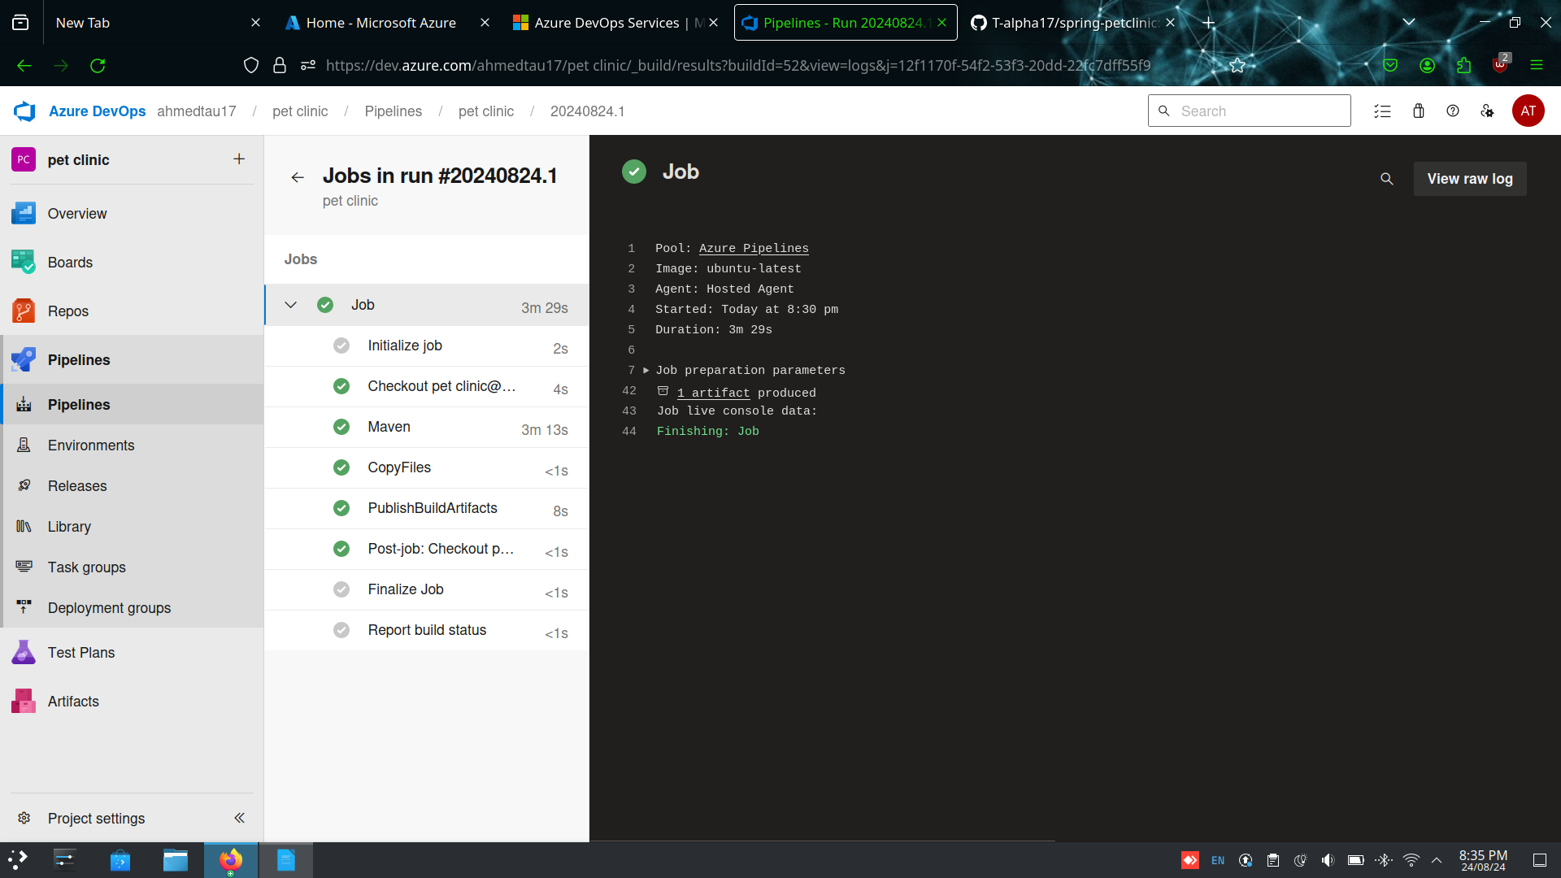

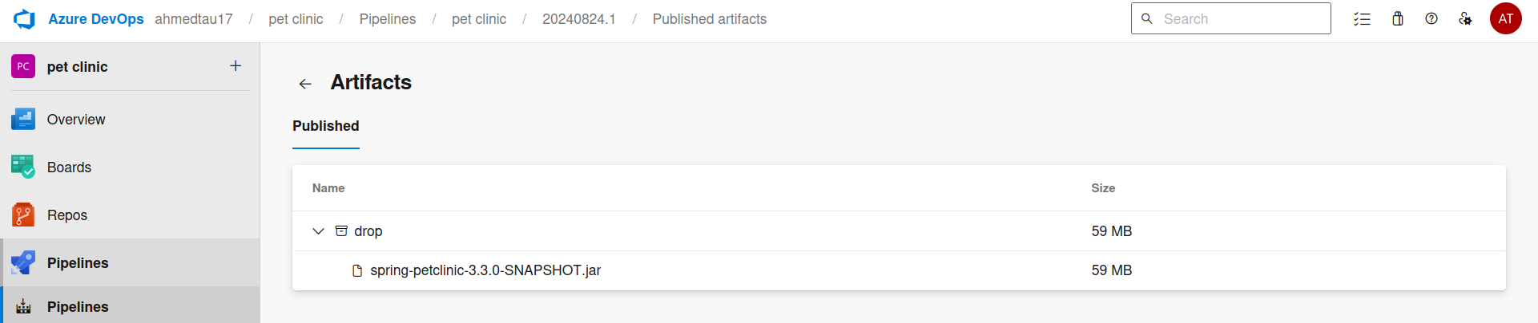

Step-6 : Navigate to released and create a release pipeline , make sure to add the artifact

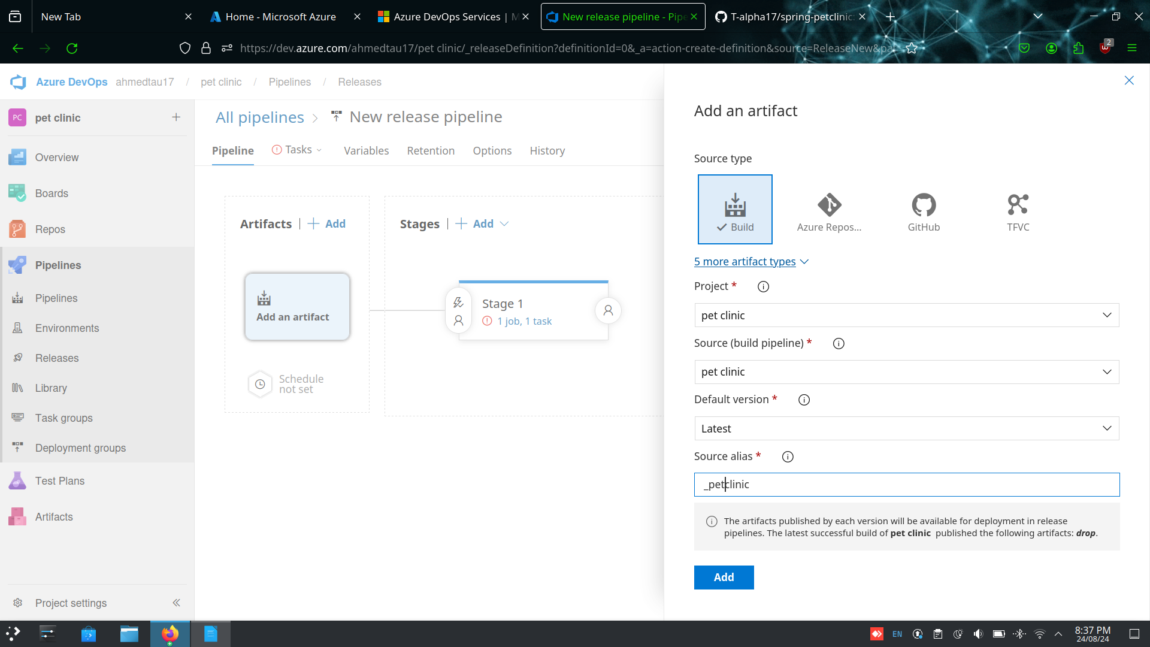

Step-7: Make sure to change the run agent to azure pipelines and select windows 2019

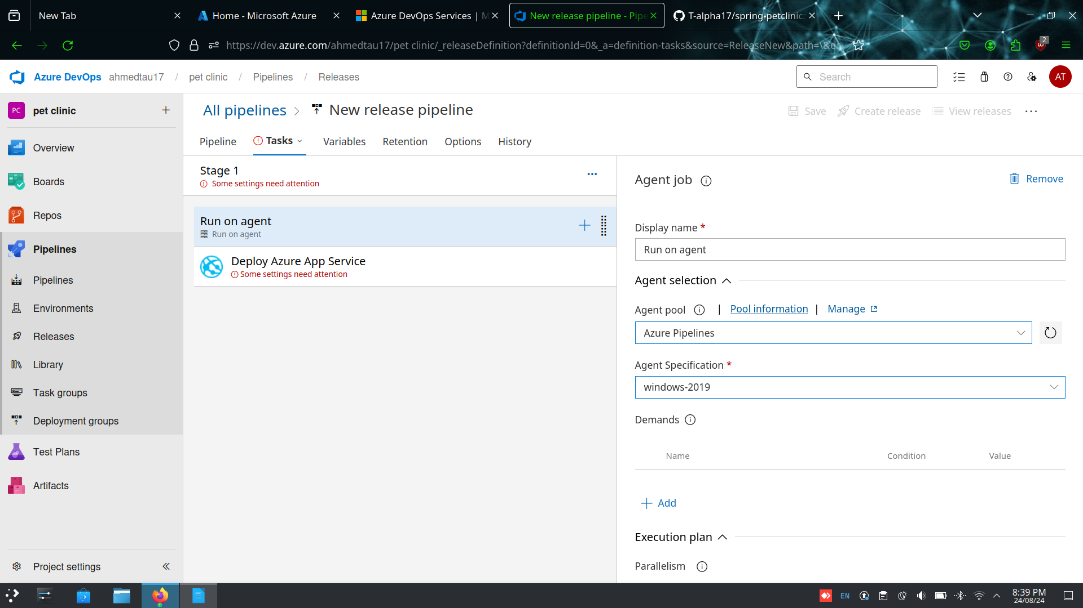

Step-8 : Make sure to add azure cli and azure app service deploy, azure cli version = 1.* and azure app service deploy = 4.*

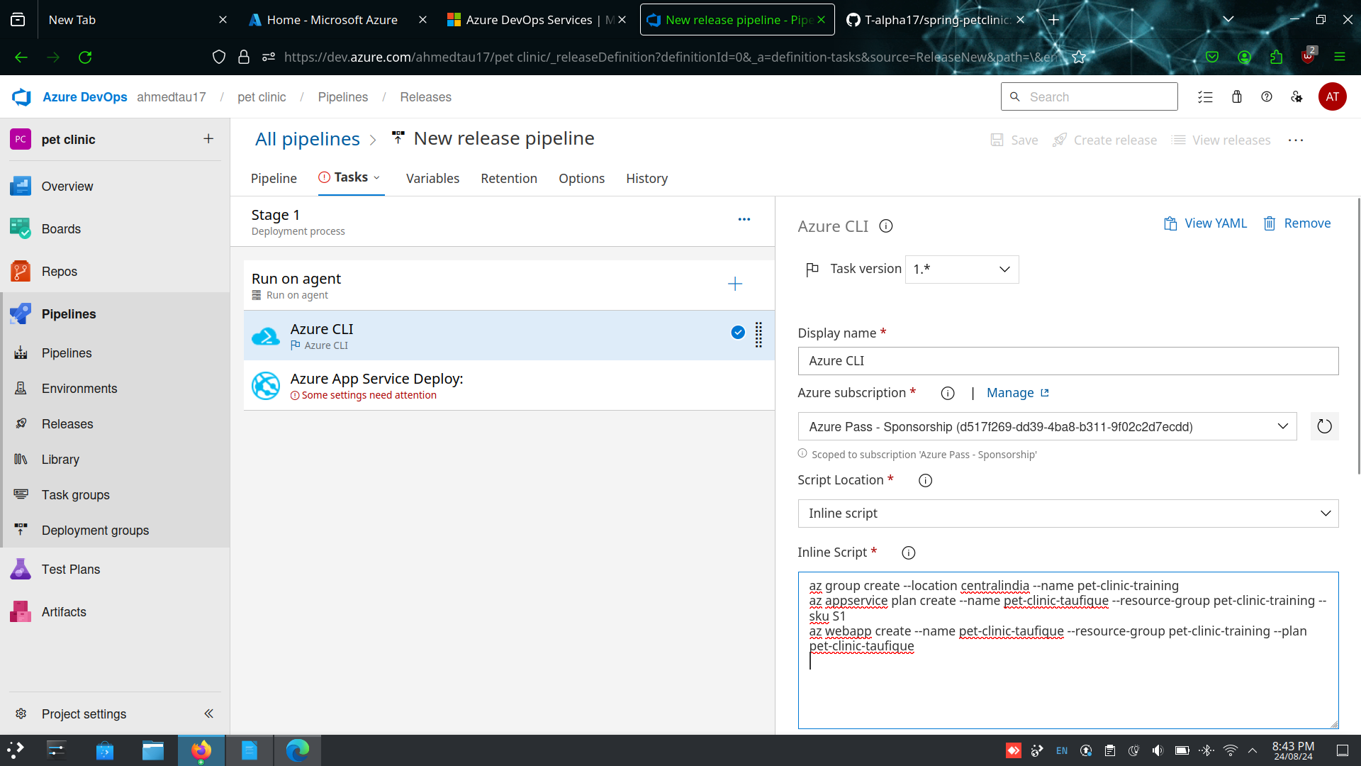

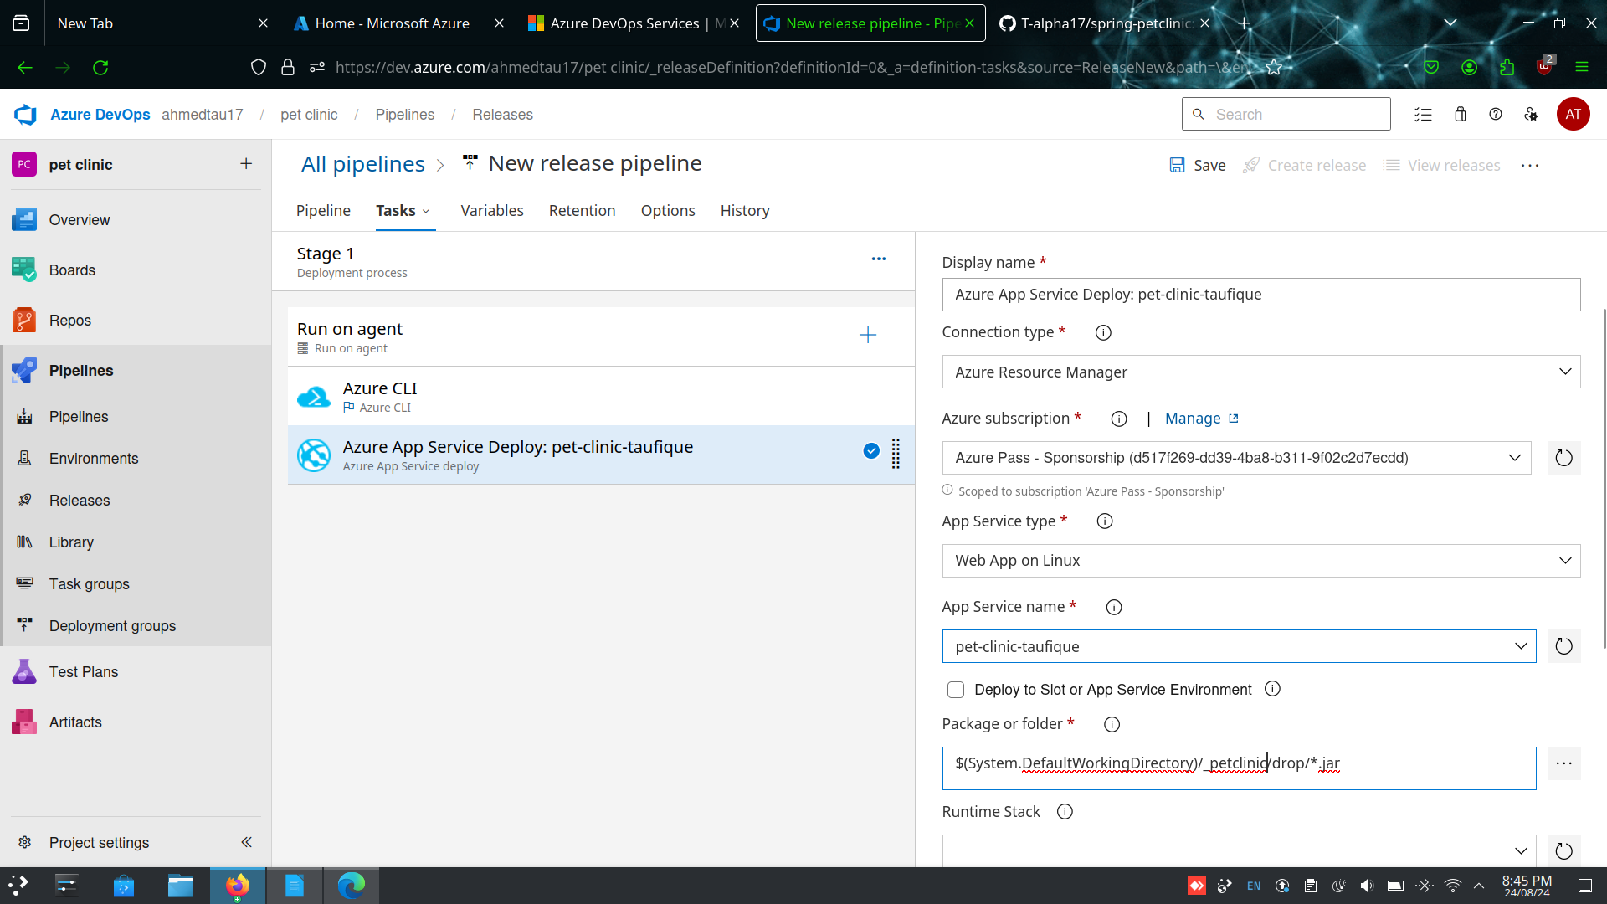

Step-9 : Create a release the pipeline

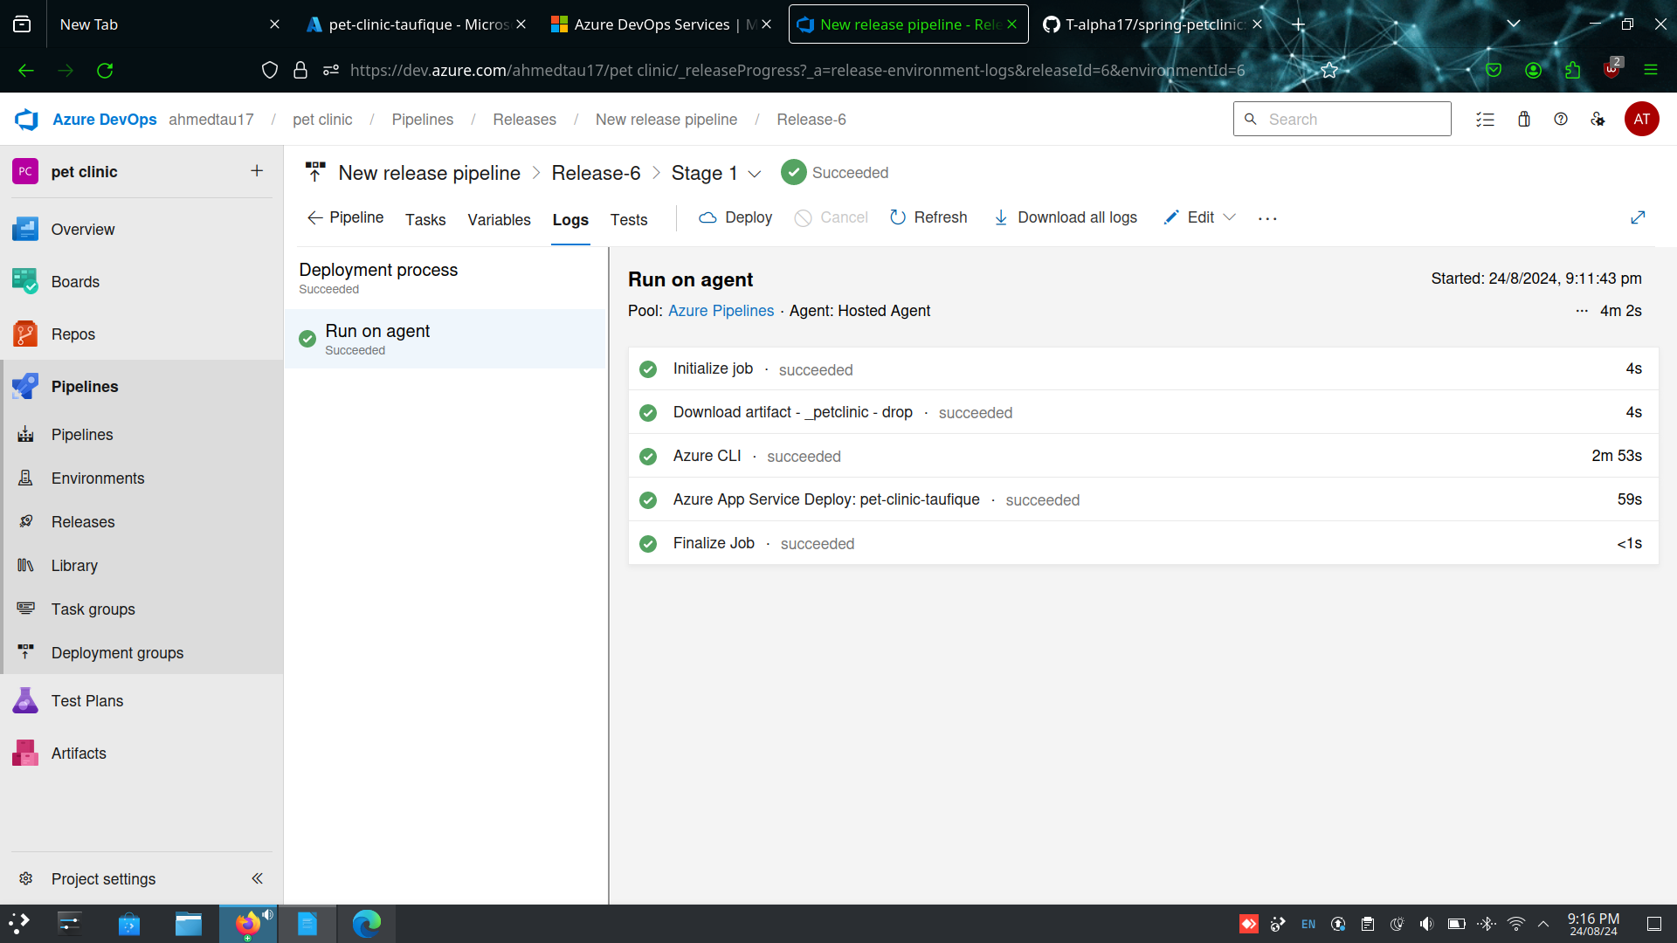

Step-10: Change the configuration and add java 17

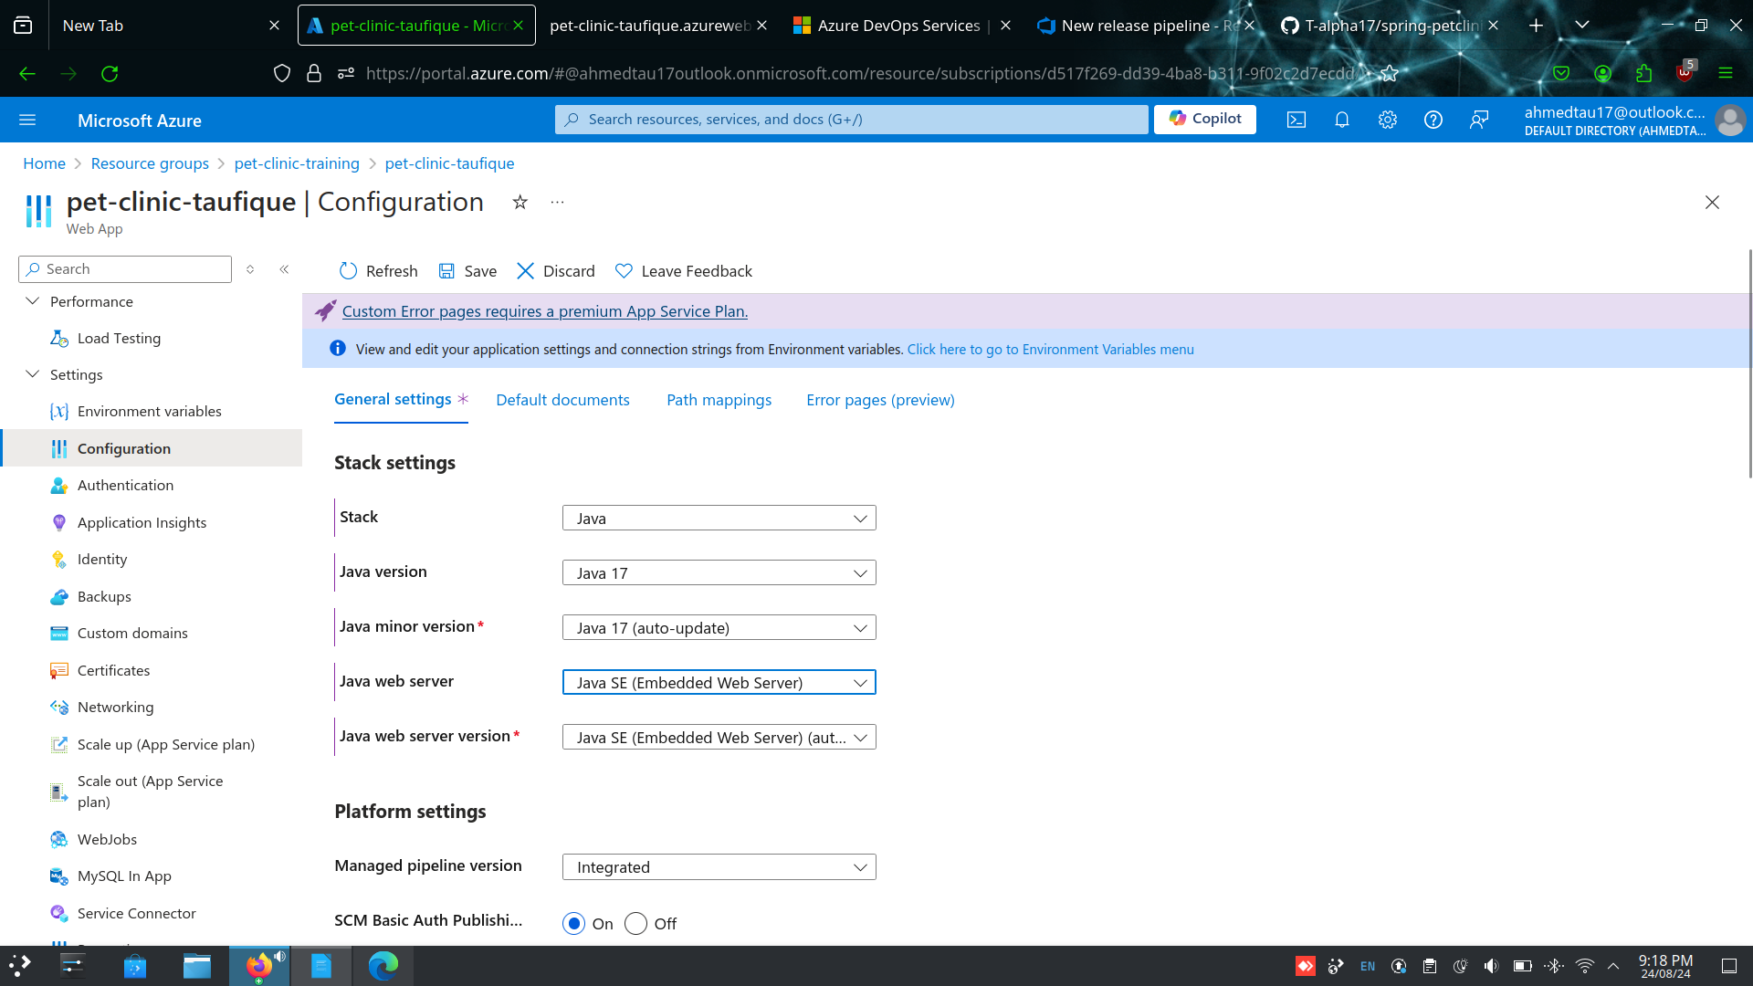

Step- 11 : click on browse and launch the web app

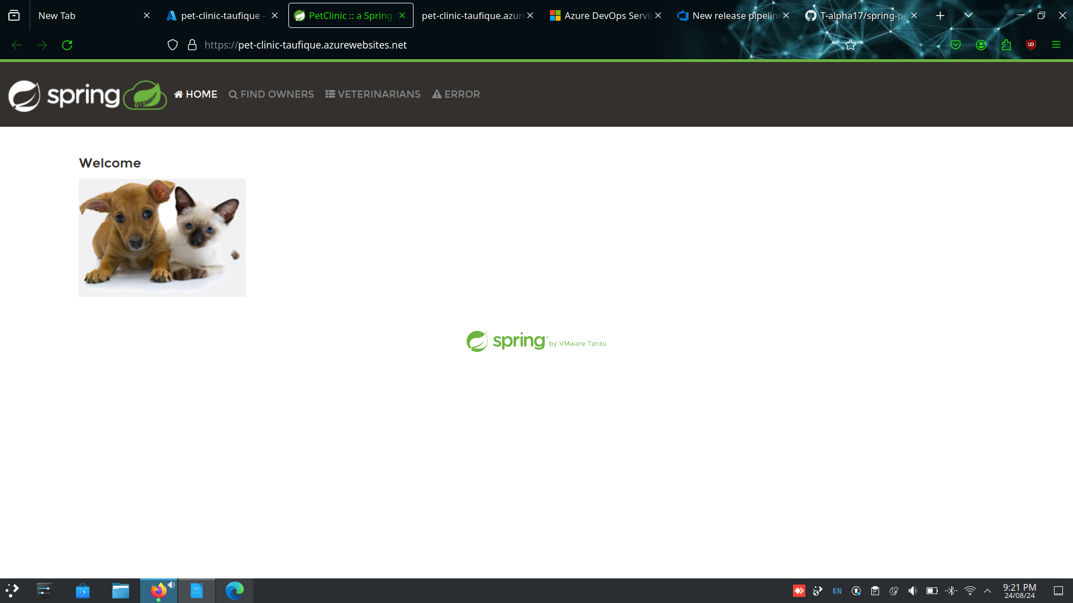

3. Create a bit bucket

A.

1. Project

Step-1: Go to bitbucket and select create and select project

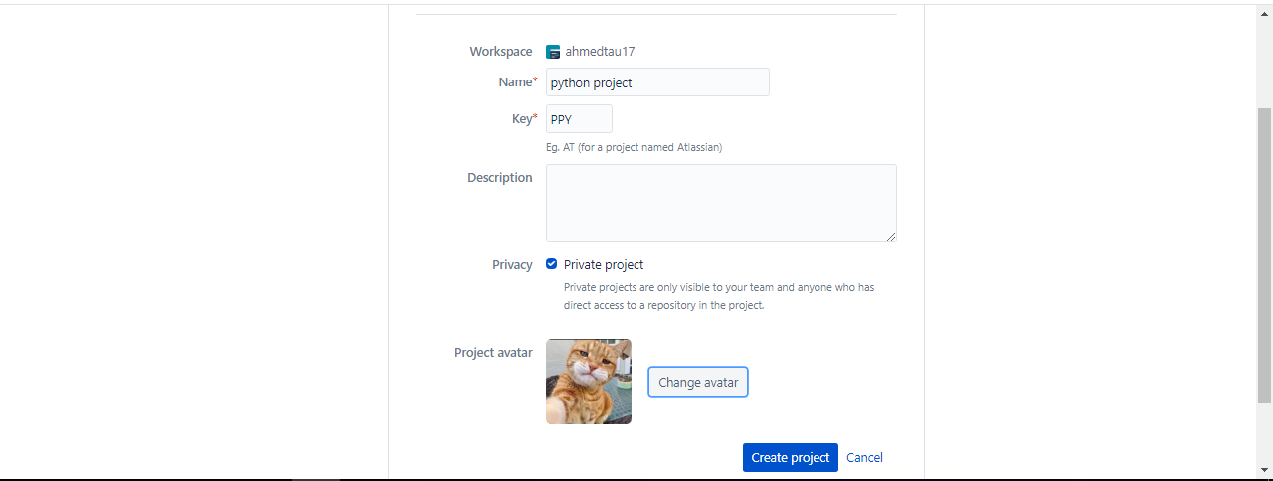

1. Repository

Step-1 : Click on create new repository or import a project from github

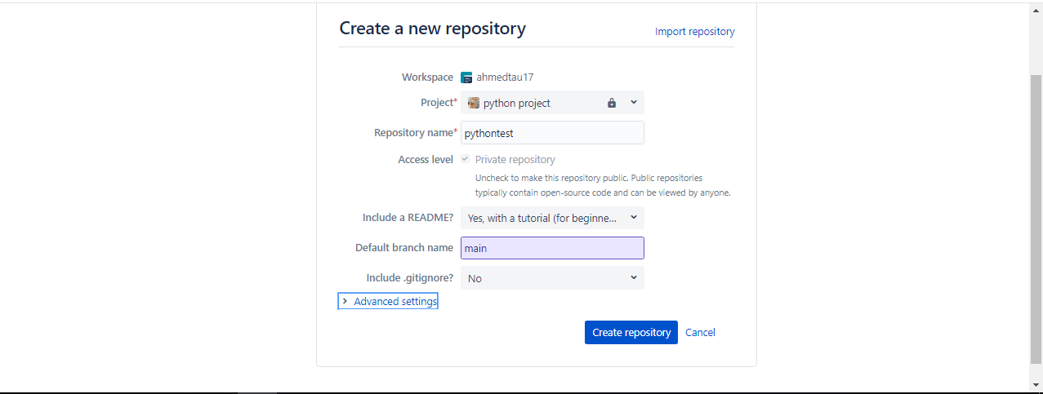

Step-2: Create a virtual machine to connect to bitbucket and clone the repo via ssh

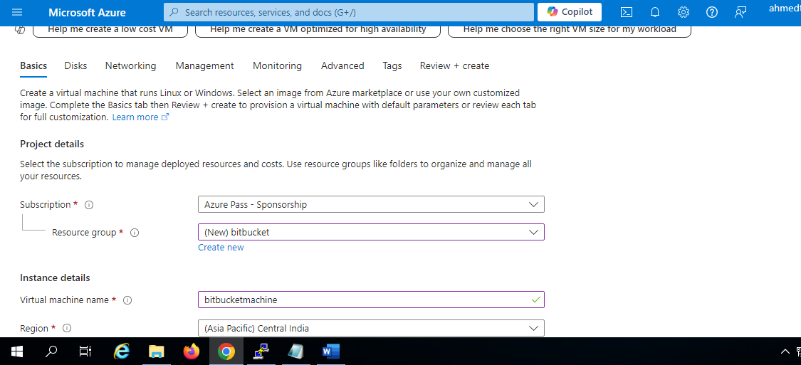

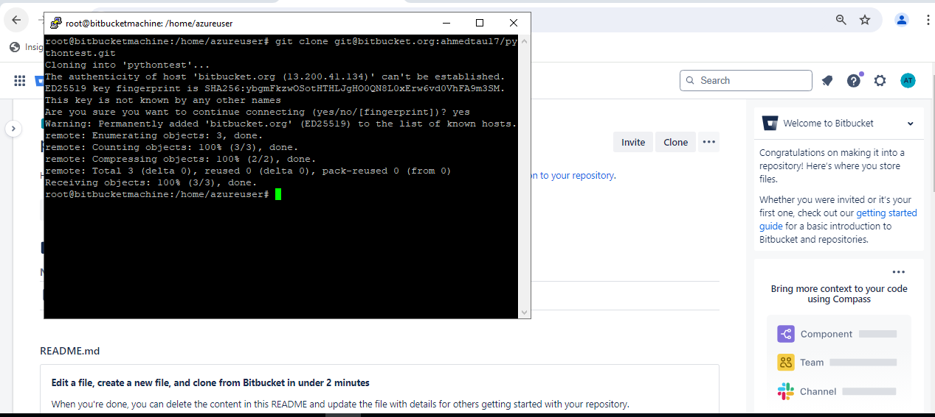

Step-3 : Create a test file hello_world.py

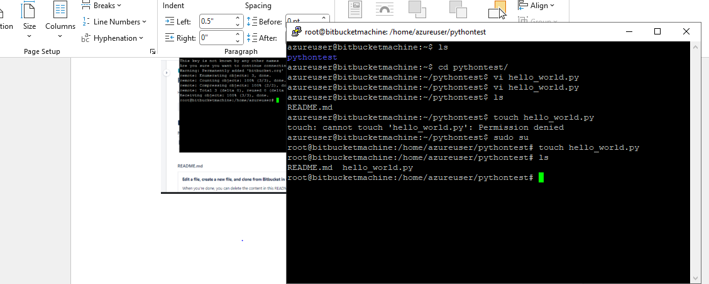

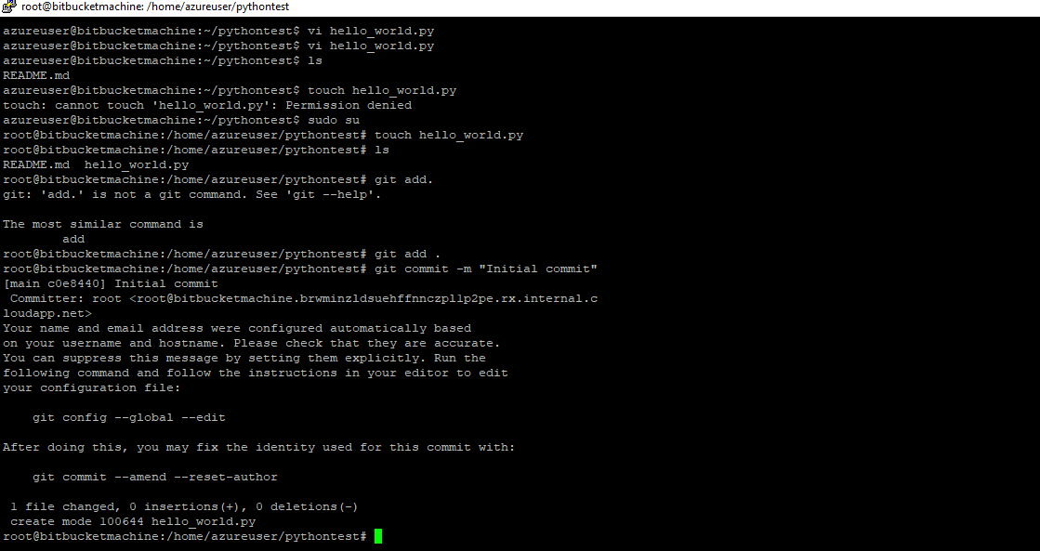

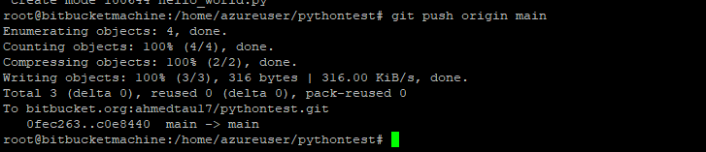



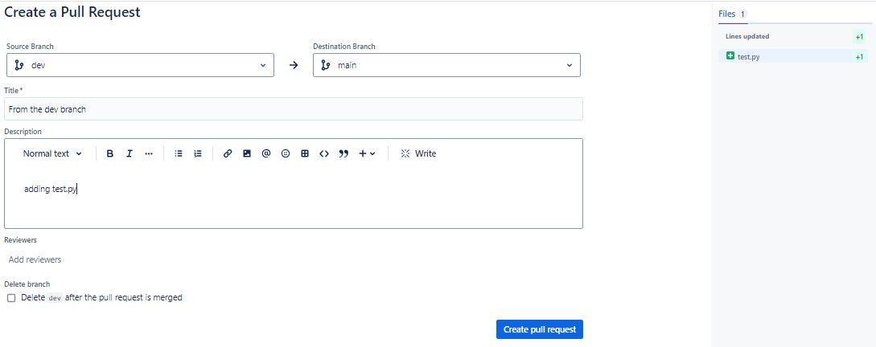

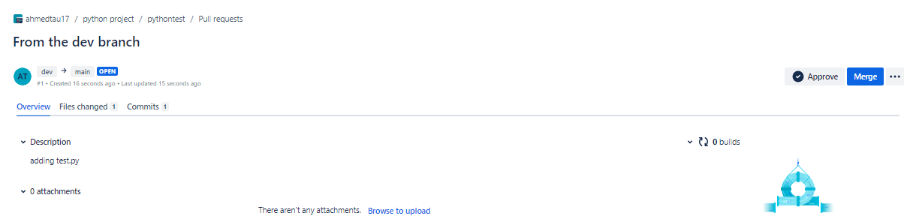

4. Create jenkins freestyle pipeline for the spring pet clinic jar creation?

A.

Step-1 : Go to Jenkins and add a new item and select freestyle project

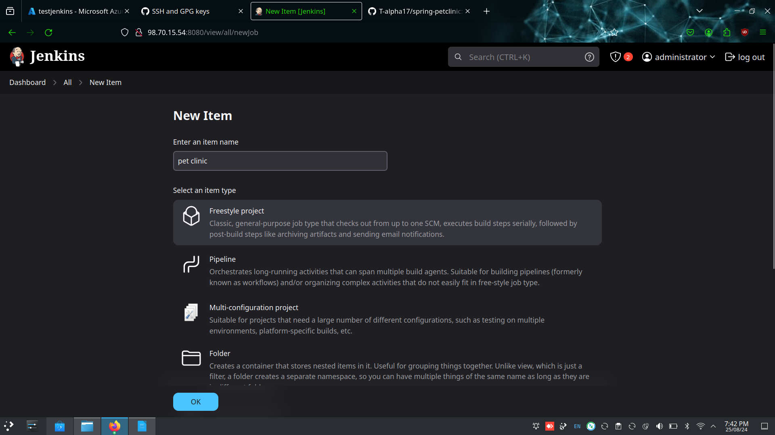

Step-2 : Configure the project and add the url of the spring pet clinic

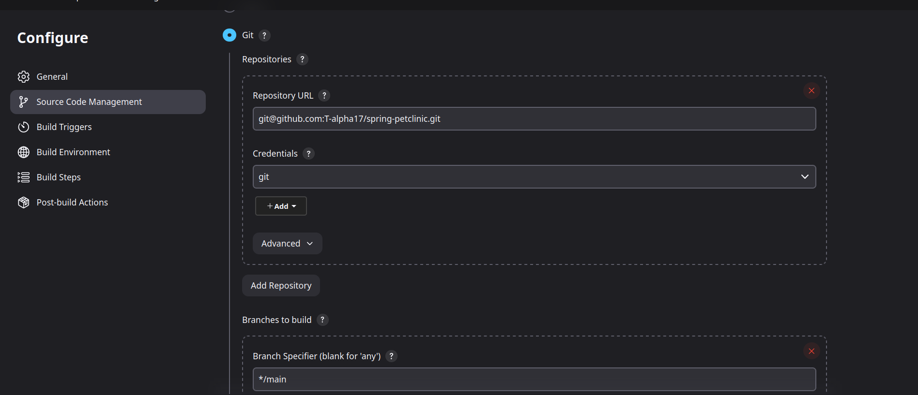

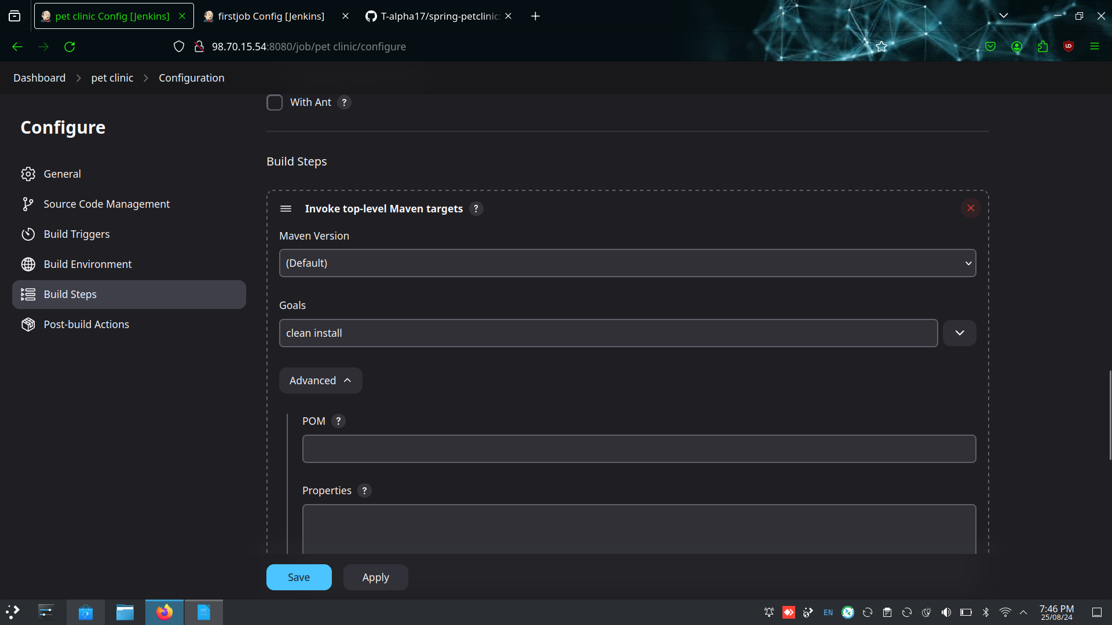

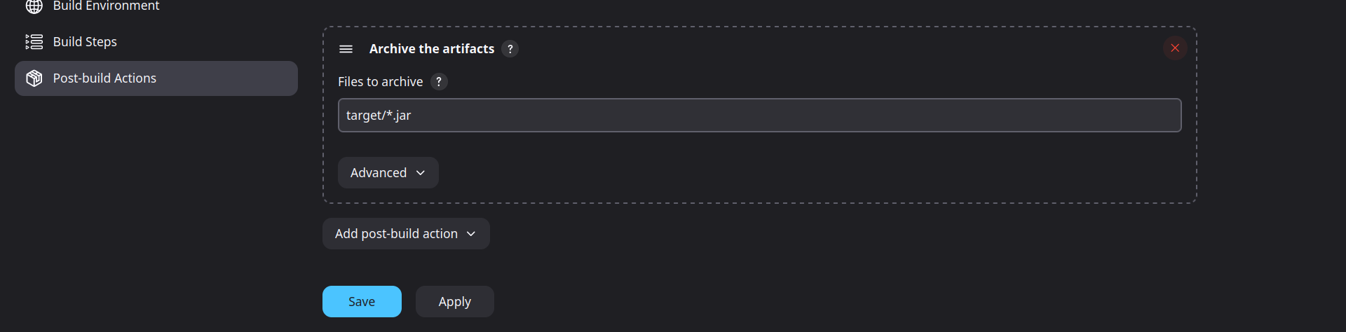

Step-3: Check the jar file in the artifacts

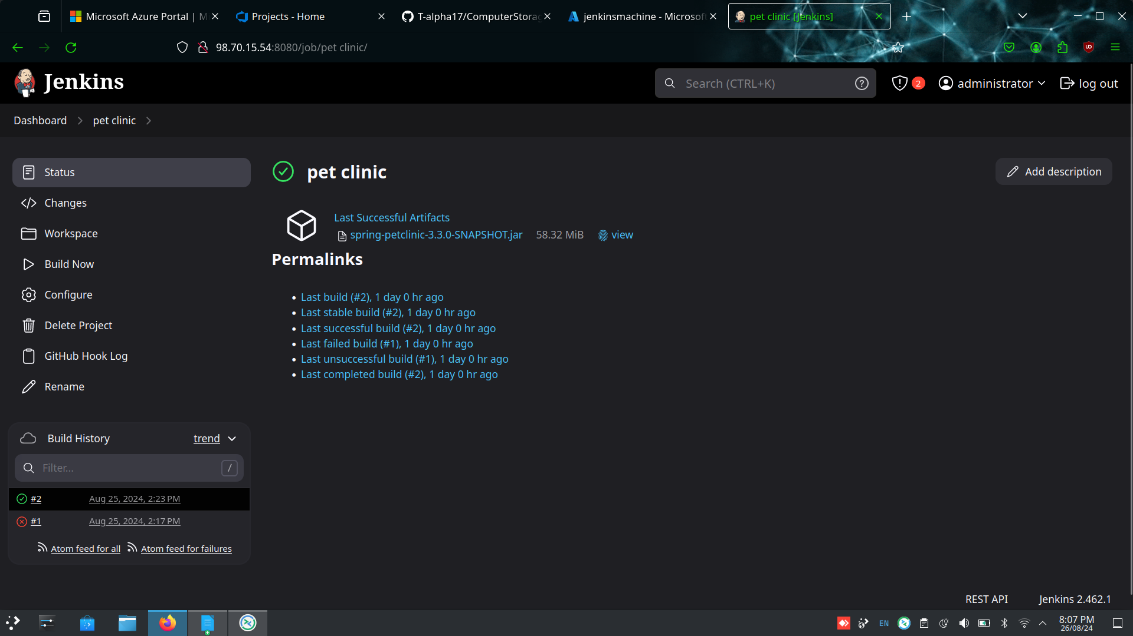

5. Create a pipeline in jenkins for spring pet clinic jar creation?

A.

Step-1: Create a new item name pet clinic pipeline and select the item type as pipeline

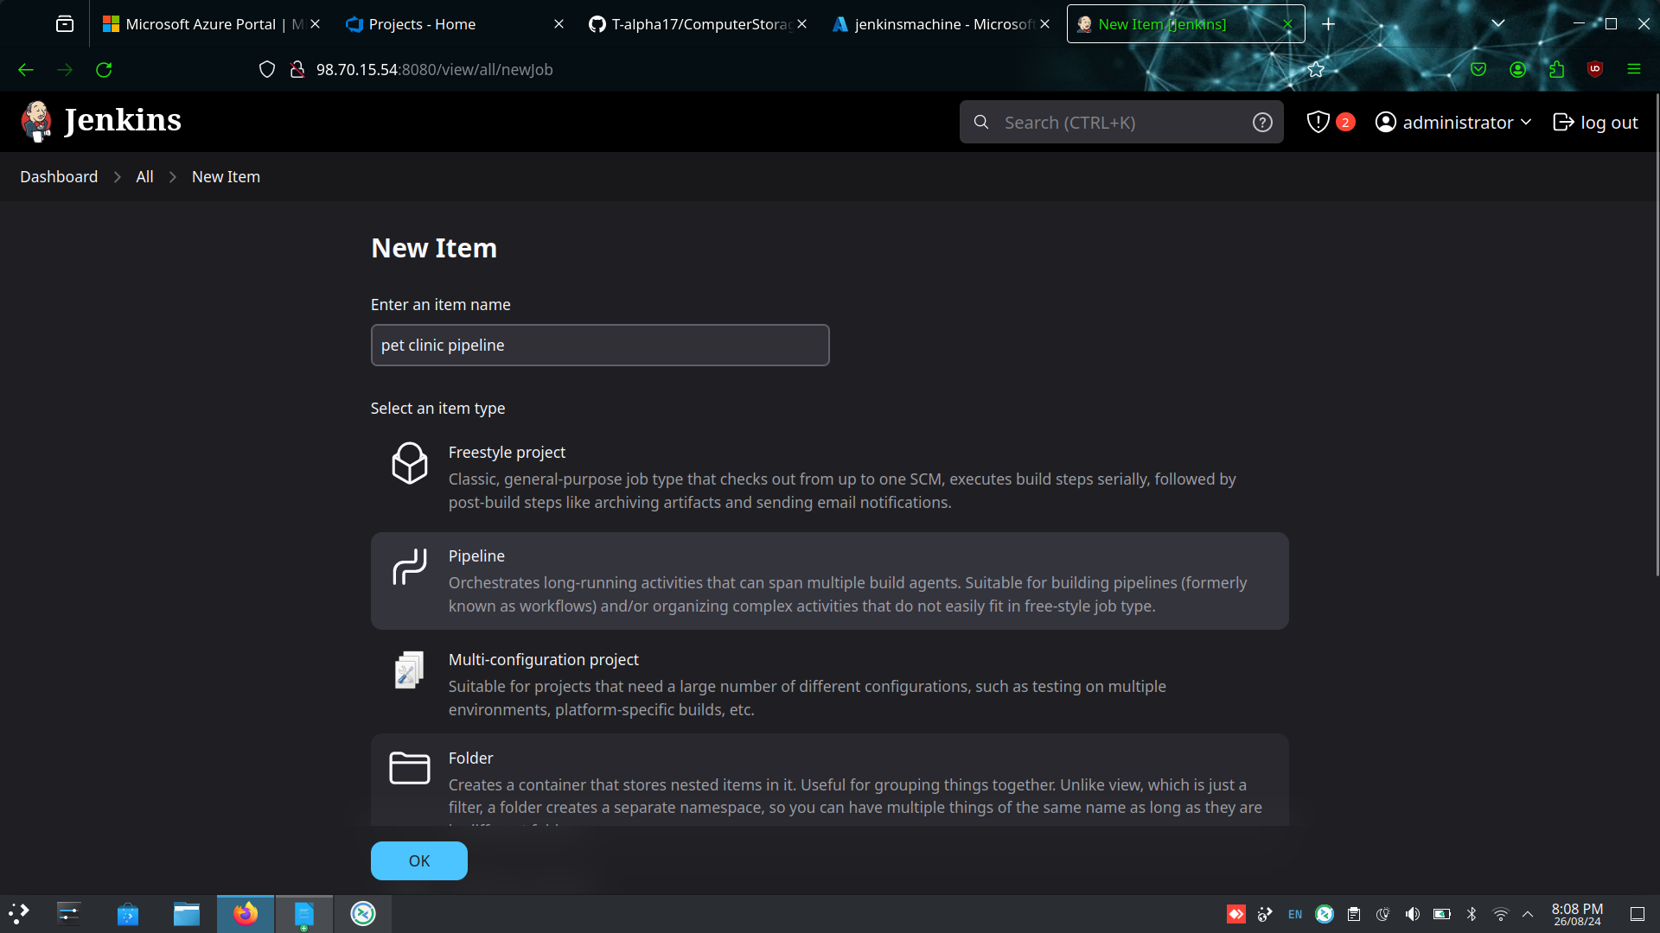

Step-2 : Configure the require parameter and write the pipeline code

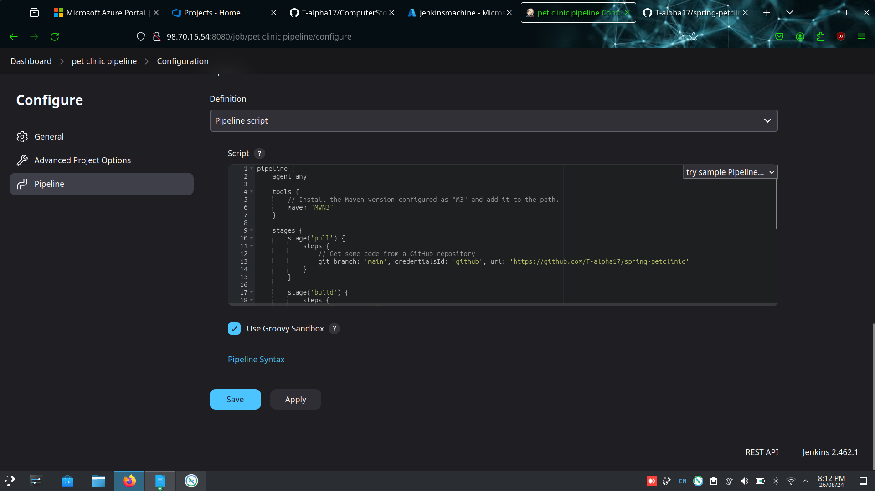

Step-3: Click and build and build the artifacts

